Britannia Square Residents’ Association

COMMITTEE MEETING

Minutes of the meeting held on Tuesday 3 February 2015
At 8:20 pm at 33 Britannia Square

- Attendance

Apologies:
Kate Tait

Present:
Anna Hooper, Chairman
John Ball
Clive Collings
Claire Dallaway
David Greenhill
Nicky Neville-Lee
Ian Terry

Guest:
Robin Dallaway

- Minutes of the Previous Meeting

The minutes of the meeting held on 18 November 2014 were agreed.

Matters Arising:
Please see agenda items.

- BSRA Website

The committee are most grateful to Robin Dallaway who has kindly offered his expertise and resources to build a website for the BSRA. Robin issued a design for the home page and a website page plan and explained his ideas. Robin can organise the building of the website which will be accessed at www.britanniasquare.org

This web address has already been purchased and a dummy home page with potential sponsors’ logos is now visible:
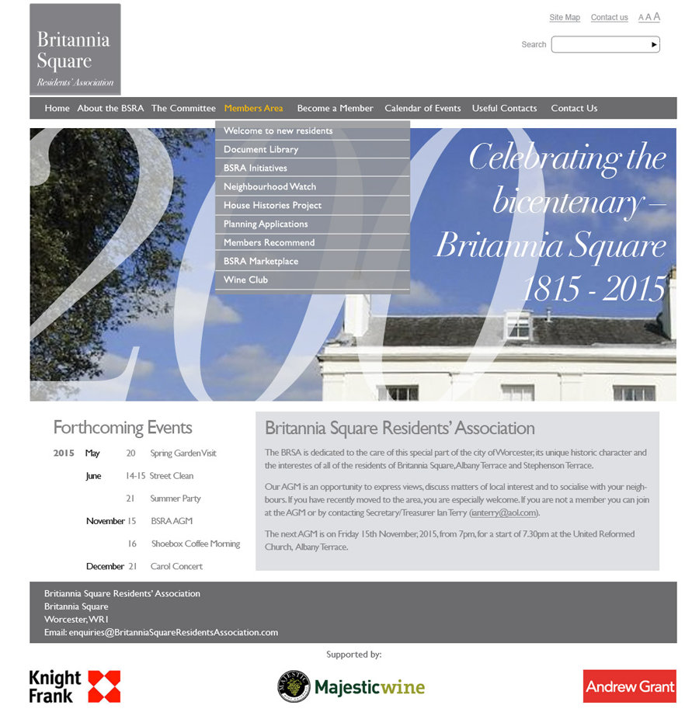
Content for the website will be managed and loaded by Robin through the facilities of his company to ensure security and control and will be refreshed with new information at regular intervals. Ian Terry will provide existing and historical documents and images for the initial load and will collate future submissions to Robin.

Robin advised the likely costs of web hosting at around £100 p.a. We agreed that we should attempt to cover the running costs of the website by displaying sponsors’ logos wherever practical on the website. We felt that Knight Frank, Andrew Grant and Majestic Wines were suitable potential sponsors whom we believed might be willing to pay for their logos to be displayed. Following discussions at the meeting and subsequently we agreed to seek £200 p.a. from each sponsor but would accept a smaller sum if offered. Anna Hooper, Ian Terry and John Ball will arrange to approach the potential sponsors. Action Anna Hooper, Ian Terry & John Ball

The Committee was delighted with this great leap forward in our vision of a BSRA website and expressed its gratitude and thanks to Robin for his most generous support.

- Street Signs

David Greenhill had issued a comprehensive survey and proposal for renovation of the many street signs within our part of the Conservation Area. We were very impressed by the detail and quality of this document and are most grateful to David for his time and expertise. David pointed out the very specific paint specifications and the constraints of working beside a public highway. Anna Hooper and David Greenhill will meet Councillor Simon Geraghty to seek funding and approval. We are optimistic of obtaining funding if we provide the labour by the residents. We will feature this project in our Spring Newsletter. Action Anna Hooper & David Greenhill

- Events

5.1. Review of Christmas Carols Party, Sun 14 December 2014
This event was very successful and is running to a tried and tested formula. Our thanks to the various performers.

5.2. Spetchley Park Gardens Visit, 6pm Wed 20 May 2015
We will advertise this event in the Spring Newsletter.

Anna Hooper will prepare a flyer in late April for Ian Terry to print. Action Anna Hooper & Ian Terry

5.3. Street Clean, Sun/Mon 14/15 June 2015
Anna Hooper will contact Heather Bainbridge to confirm arrangements. Action Anna Hooper

We will advertise this event in the Spring Newsletter.

5.4. Bicentenary Summer Party 2015, Sunday 21 June 2015

We are keen to learn which house is referred to in the historical references to the first building in the Square being in 1815. We speculated that it might be no. 46. Claire will enquire with the owners.
Action Claire Dallaway
Ian Terry will promote the house histories project with those who have expressed an interest.
Action Ian Terry
- Spring Newsletter

Several items have already been referenced for inclusion in the Spring Newsletter. Anna Hooper will collate the copy for composition and printing by David Greenhill. Action Anna Hooper & David Greenhill

- Committee Reports

7.1. Planning
Nothing new to report.

7.2. Highways
We noted the very poor pruning work done by RGS on the tree opposite Clive Collings and David London’s houses. We hope that it can be improved following representations by them to RGS.

We are already in discussions about improving the Springfield hedge, with little effect to date.

The apparently collapsing sewer in Albany Terrace has still not been remedied.

Other matters were deferred to the next meeting.

7.3. Lighting
Nothing to report.

7.4. Neighbourhood Watch
See separate minutes of the meeting earlier this evening.

7.5. Wine Club
No recent events.

7.6. New Members
No change in overall membership.

7.7. Finance and fund-raising
The bank balance is £326.06.

- Any other business

We are lacking a representative on the University of Worcester’s Forum and are keen to appoint someone.

- Dates of future meetings & events

Tue 21 Apr 2015 – Committee Meeting at 52 Britannia Square
Wed 20 May 2015 - Spetchley Park Gardens Visit
Sun/Mon 14 & 15 Jun 2105 - Street Clean
Sun 21 June 2015 - Bicentenary Summer Party

